**Python Basics**

**Assignment 1**

1. In the below elements which of them are values or an expression? eg:- values can be

integer or string and expressions will be mathematical operators.

*

“hello”

-87.8

-

/

+

6

**Answer1** -In the below elements, these are values or expressions:

* Values: 'hello', -87.8, 6
* Expressions: *, -, /, +

2. What is the difference between string and variable?

**Answer 2**-Difference between string and variable:

* String: A string is a sequence of characters enclosed in single or double quotes. It represents text or characters.
* Variable: A variable is a name given to a value or an object in memory. It can store different types of data, including strings.

3. Describe three different data types.

**Answer 3**- Three different data types:

* Integer: Represents whole numbers, e.g., 5, -10, 0.
* Float (Floating-Point): Represents decimal numbers, e.g., 3.14, -0.5, 2.0.
* String: Represents sequences of characters, e.g., "hello", 'Python', "123".

4. What is an expression made up of? What do all expressions do?

**Answer 4-**An expression is made up of operators and operands. It can involve mathematical operators (e.g., +, -, *, /) and values (e.g., numbers or strings). Expressions perform calculations or operations and produce a result.

5. This assignment statements, like spam = 10. What is the difference between an

expression and a statement?

**Answer 5-**The key difference between an expression and a statement is that an expression evaluates to a value, whereas a statement performs an action. In the assignment statement 'spam = 10', 'spam' is a variable, and '10' is an expression that evaluates to the value 10.

6. After running the following code, what does the variable bacon contain?

bacon = 22

bacon + 1

**Answer 6** After running the following code, the variable 'bacon' contains 22. 'bacon + 1' is an expression that adds 1 to the current value of 'bacon'.

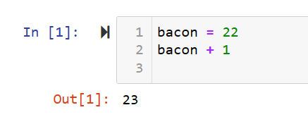

7. What should the values of the following two terms be?

'spam' + 'spamspam'

'spam' * 3

**Answer 7** The values of the following two terms should be:

* 'spam' + 'spamspam': This results in 'spamspamspam'.
* 'spam' * 3: This results in 'spamspamspam'.

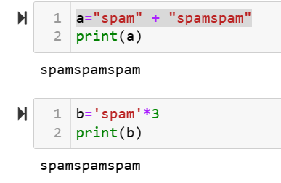

8. Why is eggs a valid variable name while 100 is invalid?

**Answer 8**- 'eggs' is a valid variable name because it follows the rules for variable names in Python. Variable names must start with a letter (a-z, A-Z) or an underscore (_) and can be followed by letters, digits (0-9), or underscores. However, '100' is invalid as a variable name because it starts with a digit, which is not allowed in Python variable names.

9. What three functions can be used to get the integer, floating-point number, or string

version of a value?

**Answer 9**-Three functions for type conversion:

* **int()**: Converts a value to an integer.
* **float()**: Converts a value to a floating-point number.
* **str()**: Converts a value to a string.

10. Why does this expression cause an error? How can you fix it?

'I have eaten ' + 99 + ' burritos.'

**Answer 10**-The expression 'I have eaten ' + 99 + ' burritos.' causes an error because you are trying to concatenate a string ('I have eaten ') with an integer (99) directly.

To fix it, you can convert the integer to a string using **str(99)** as

'I have eaten ' + str(99) + ' burritos.'